
Project Report-2

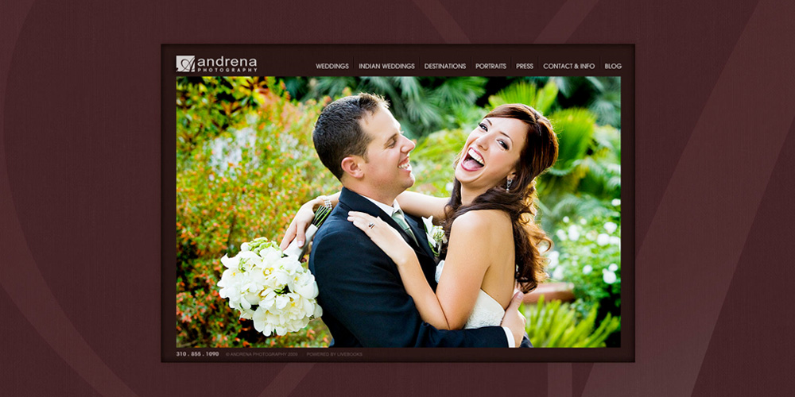

Photography Business
Group Members:
Zoebali Maknojia (50)
Zankhan Joshi (38)
Disha Shah (88)
Nikki Punjabi (78)

Goal for 2nd fortnight :
Planned :
We had planned to visit studio to gather some information about different departments.
Actual :
We visited 2 studios and they provided us information about the Capture Department as follows:
Actors:
Expert Photographer: An Actor who is expertise in Particular type of photography.
Assistant Photographer: An Actor Who works under the Expert Photographer and helps in achieving client’s needs.
Light men: An Actor who arranges proper lighting for the event.
Extra Staff: Helper who helps in some extra activity.
Tools:
Cameras:
Photo Camera:
SLR (Single Lens Reflex): This type of camera is used in low budget events. It contains 35mm Negatives, size of sensor is “APC C” size and around 10mega pixels.
DSLR (Digital Single Lens Reflex): This type of camera is used in High budget events. It captures image digitally, which used CCD (Charge Couple Device).
Video Camera:
DV (Digital Video): These Cameras are used for low budget events. It has the resolution size of 720x576 pixels.
HD (High Definition): These Cameras are used for High budget events. It has resolution size of 1280x576/1440x1080 pixels.
HDV (High Definition Video (Full HD)): These Cameras are used for capturing pictures in 1920x1080 pixels of resolution size.

Lenses:
Prime Lens: These Lenses are used for SLR cameras and used for low light and sharpness.
Full Frame Lens: These Lenses are used for DSLR cameras, which has 2.8 full lenses.
Tripods:
This equipment is used with camera for capturing smooth and constant images and video.
Lights:
Used to provide proper lighting for capturing perfect shots.

Activity anticipated for next report :
We are planning to get detailed information about rest of these departments.

